Name: Class:
Introduction
Polythene
Polythene, or poly(ethene), is used extensively as the plastic in plastic bags for fruit and vegetables, garbage bin liners, squeeze bottles, cling wrap and many other items.
The very large molecules making up polythene make it a little different in structure from most other covalent molecular compounds. Yet it still behaves like a covalent molecular compound. It melts at temperatures between 120 and 140ºC, it is flexible and does not conduct electricity.
As with all polymers, the very large molecules of polythene are made up of repeating units. These repeating units are –CH₂– as shown in the following line structure:
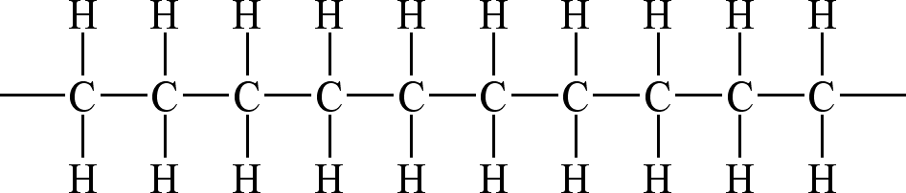
A polythene molecule can contain up to 100 000 repeating units.
Polythene is prepared by reacting the monomer ethene, CH₂ = CH₂, in the presence of a catalyst. Monomers are the small molecules used to make polymers. Two different kinds of polythene, a low density polymer and a high density polymer, can be made depending on the conditions used to form them. Low density polythene has a lower melting point, is more flexible and more transparent, but is not as strong as the high density polythene. The low density form is the one used for the plastic bags, but the high density form is used for water pipes and electrical cable insulation. The differences between these two forms of the same polymer are due to the variation in the structures of their chains. In high density polythene, the chains are very linear, but in low density polythene, the chains are branched, as shown below, where a line is used to represent the chains of CH₂.

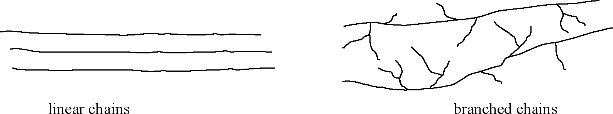

Branched chains cannot fit as closely together as the linear chains.
All of the plastic materials that are commonly used, such as polystyrene, bakelite, Teflon and PVC, are polymers similar to polythene. They have the same long chains of carbon atoms joined one to the other, but they have some different groups joined to this chain. For example PVC has chlorine atoms covalently bonded to some of the carbon atoms in the long chains as shown below

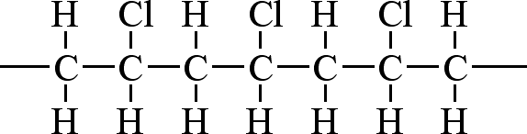
No. | Question | Answer
 | Propose a reason why the form of polythene with the branched chains is called low density polythene.
a Explain why a plastic bag melts easily if touched with a hot object.
b Suggest why low density polythene has a lower melting point than high density polythene?

 | Suggest why high density polythene is less flexible than low density polythene.
 | Despite there being many electrons in a molecule of polythene, it does not conduct electricity. Explain why.
 | Draw an electron dot diagram and a line structure of ethene. (In a line structure, a single line represents a pair of electrons.)
Teflon, the non-stick coating sometimes used on saucepans, is prepared from the monomer tetrafluorethene, C₂F₄.
a Draw an electron dot diagram and a line structure of tetrafluoroethene.
b Draw a line structure of a small portion of the polymer Teflon.
 | Draw a line structure and an electron dot diagram of the monomer used to produce the PVC molecules shown on page 1.

